DIT 637 Smart and Secure Systems
TT01: Experiencing Cloud Computing – Full-Stack Web Application
6/14/2024 Developed by Clark Ngo
07/30/2025 Reviewed by Rajdeep Singh Golan
03/04/2026 Improved by Clark Ngo
School of Technology & Computing (STC) @ City University of Seattle (CityU)

Key Concepts and Tools for Web Development
- Frontend: To create the visual part of websites and applications that users interact with, like the layout of an e-commerce site.
- React: To efficiently build dynamic and responsive user interfaces, such as the interactive components of Facebook.
- Movie Search: To practice and demonstrate the capabilities of React in creating real-world applications, like searching for movies on Netflix.
- Codespaces: To provide a cloud-based development environment that's easy to set up and use from anywhere, similar to Google Docs but for coding.
- GitHub as Repo: To store and manage code with version control, making collaboration easier, just like using Google Drive for sharing documents.

User Case – Movie List Display & Search
💡 A user story helps by clearly defining the user's needs and goals, ensuring that development efforts are focused on delivering value to the end-user.
As a movie enthusiast, I want to search and browse a list of movies with details such as title, genre, and year, so that I can easily find information about movies I am interested in.

Features Included
- Movie List Display:
  - What: Shows a list of movies with their titles, genres, and release years.
  - Why: To provide users with a comprehensive view of available movies.
- Search Functionality:
  - What: An input field that filters the movie list based on the user's search term.
  - Why: Allows users to quickly find specific movies by typing part of the title.

Flow of Interaction
- Initial View:
  - The user sees a list of all available movies along with a search bar at the top.
- Using the Search Bar:
  - As the user types into the search bar, the list of movies dynamically updates to show only those that match the search term.

Technical Implementation
- State Management: Uses React's useState hook to manage the search term and filtered movie list.
- Search Handling: Updates the displayed movie list in real-time based on user input.
- Styling: Utilizes Material-UI components and custom styles for a clean and responsive user interface.

This user story ensures that users have a seamless and interactive experience when searching and discovering movies in the application.

Setup
- Open the project in GitHub.
- Create a cloud-based development project with GitHub Codespaces:
  - 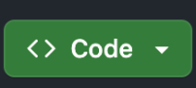
  - 
  - 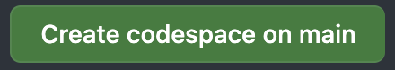
- In the terminal type:
  - npm install
  - npm start
- It should automatically open a new browser (If prompted, click “Retry”)

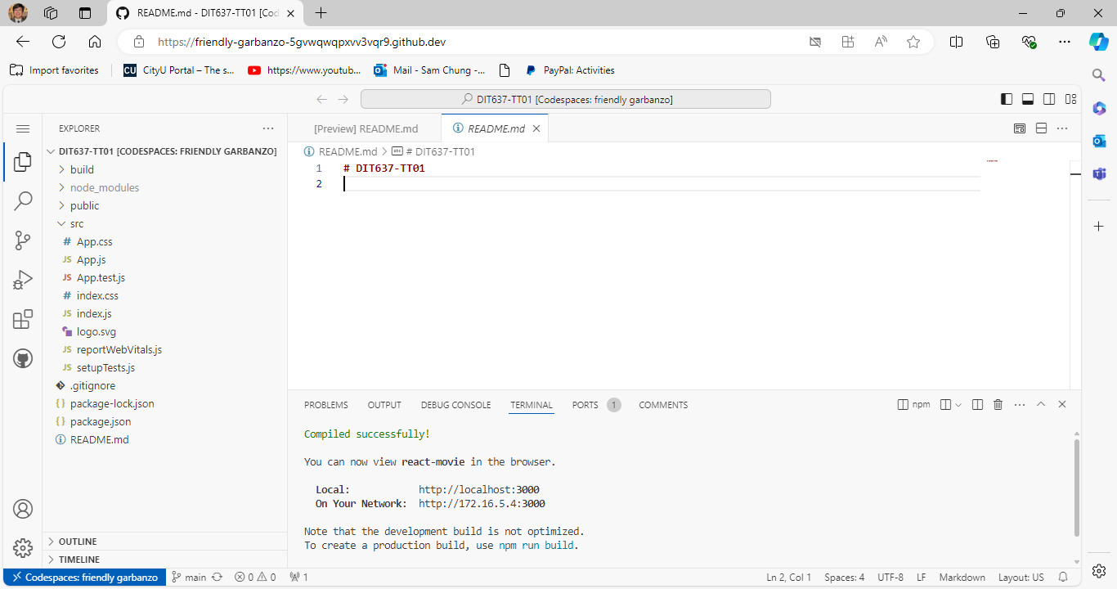

Screenshot Summary
In the provided screenshot, we see:
- Movie List Title: Displayed using Typography with the variant "h4".
- Search Bar: A TextField at the top for users to type in their search queries.
- Movie Items: Each movie is displayed in a ListItem, showing the title, genre, and year.
- Separation: Each movie item is visually separated by a border, providing a clean layout.

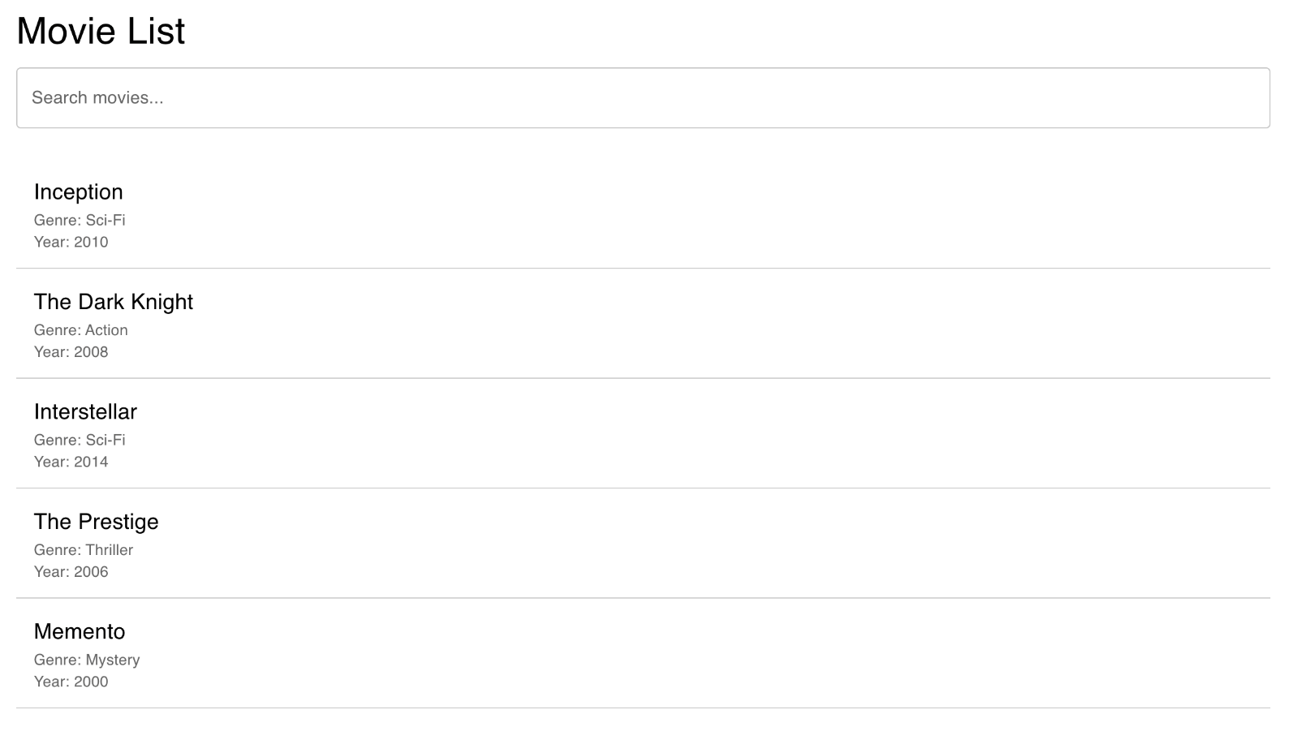
Take the screenshot of your ‘React App’ as ‘firstname_lastname_react_app.png’ by using your first and last name and upload/push to current GitHub repository.

Components Overview
- App Component:
  - The main component that contains the entire application structure.
  - It maintains the state for the movie list and search term.
  - It renders the movie list and search input.
- Container (Material-UI):
  - Wraps the entire content to provide consistent spacing and layout.
  - Styled using styled from Material-UI's system for custom styling.
- Typography (Material-UI):
  - Used for consistent text styling.
  - Here, it is used to display the title "Movie List" and movie details.
- TextField (Material-UI):
  - An input field for searching movies.
  - It updates the search term state and filters the movie list based on the input.
  - Styled using styled from Material-UI's system.
- List (Material-UI):
  - A container for the list of movies.
  - It ensures the movies are displayed as a list.
- ListItem (Material-UI):
  - Represents each movie in the list.
  - Styled using styled from Material-UI's system for custom borders and layout.
- ListItemText (Material-UI):
  - Displays the movie title, genre, and year within each ListItem.
  - Uses Typography for consistent text styling.

Code Overview
This code imports necessary React hooks and Material-UI components for building and styling the movie list application. The following code is present under src/App.js
- React Hooks: Enable functional components to use state and other React features, making the code more concise and easier to manage.
  - Functional Components: Simplified React components defined as functions, offering a more concise syntax and easier testing compared to class components.
  - State in React: A built-in object for managing component-specific data that can trigger re-rendering when updated, enabling dynamic and interactive UIs.
- Material-UI: Provides a comprehensive set of components and styling tools to create a responsive and visually appealing user interface efficiently.

Sample Data for Movies: Provides a predefined list of movies with their titles, genres, and release years, used to populate the initial movie list and demonstrate search functionality.

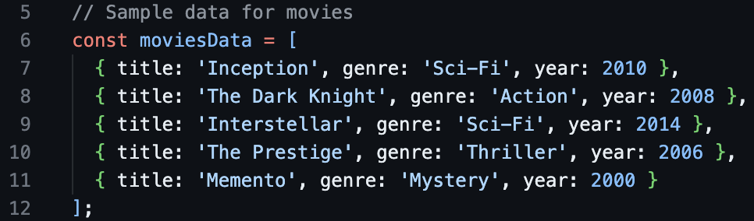

Styled Components Using Material-UI: Enhance the appearance and layout of the React application by adding custom styles to Material-UI components, ensuring a consistent and visually appealing design.

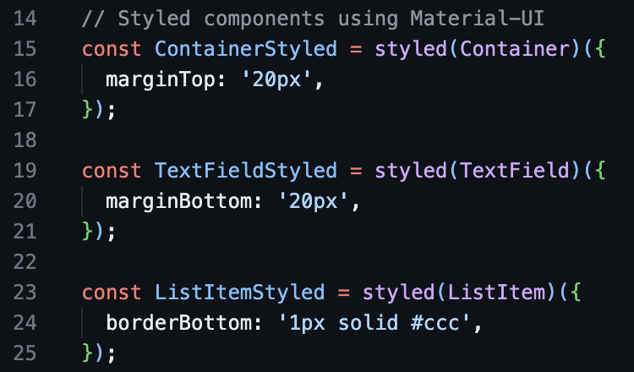

App Component: The main functional component that uses state to manage the search term and movie list, providing real-time filtering and rendering of movie data to create an interactive user interface.
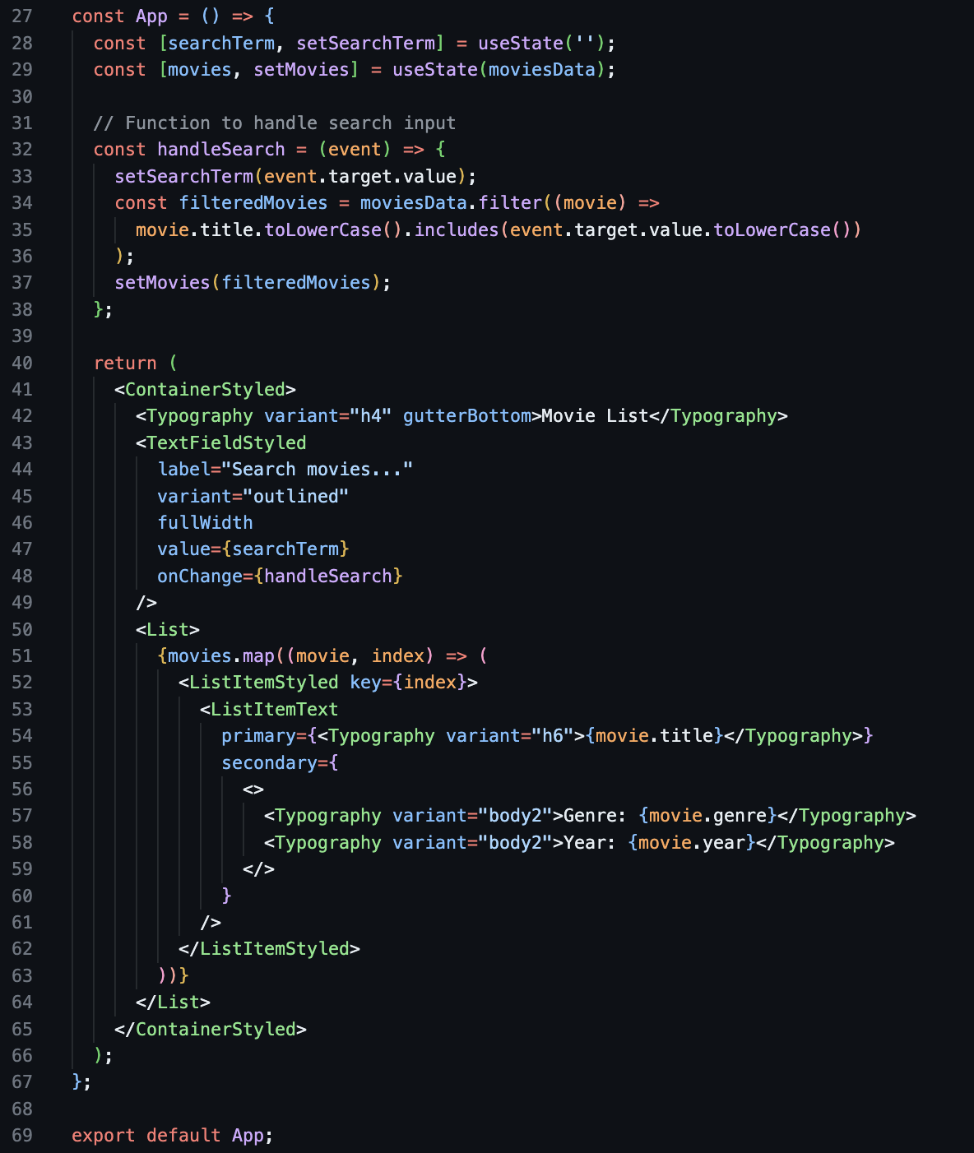

Breakdown:
App Component Definition:

- What: Defines the main functional component of the application.
- Why: Serves as the entry point for rendering the user interface.

State Declarations:

- What: Declares state variables for managing the search term and movie list.
- Why: Enables dynamic updates and re-rendering when the search term changes or the movie list is filtered.

Handle Search Function:

- What: Function to update the search term and filter the movie list based on user input.
- Why: Provides real-time search functionality, allowing users to find movies by title.

Render Method:

- What: Renders the search input, movie list, and individual movie details.
- Why: Displays the user interface elements and ensures they update dynamically based on the search term and movie list state.

Export Default App:

- What: Exports the App component as the default export.
- Why: Allows the App component to be imported and used in other parts of the application.

AI-Assisted Documentation
Objective: Use Generative AI to help you articulate the architectural changes and key concepts you implemented in this lab.
Instructions:
- Select a Key Snippet: Identify the most important code you modified in this lab.
- Prompt an AI: Use a Large Language Model (e.g., Gemini or ChatGPT) with the following prompt:
"I am a student completing a technical lab on [Insert Lab Title]. I have implemented [Insert Feature] using [Insert Tool].
Based on this code snippet: [Paste your code here]
Please write a concise, professional 3-sentence summary for my GitHub README that explains the architectural role of this code and how it contributes to a 'Smart and Secure System'."
- Update your README: Review the AI-generated explanation, edit for accuracy, and paste it into your repository's README.md.
Document | [Insert Lab Title] | [Insert Feature] | [Insert Tool]
TT01 | Cloud Computing | a movie search frontend | React and Material-UI

Pushing your work to GitHub
  - Go to Source Control on your GitHub codespaces and observe the pending changes.

  - Type the Message for your changes in the Message box on the top. For example,” Submission for TT01 – Your Name”
  - Click on the dropdown beside the commit button and select Commit & Push to update the changes to your repository main branch.
  - Select Yes when prompted.

